Fox Hunt of April 26, 2008
By Dr. Peter Rock KJ4ND

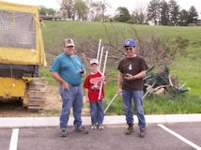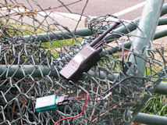

Before the fox hunt started , Stan and I had to consider whether to go ahead, as one of the foxes (Jim N4ICU) would not be there . We decided to go ahead. I packed my equipment in the car , and headed off about 9:30 a.m. I got to the Tractor Supply area about 9:40. Along the way I was talking to Tony KI4VMN, who was also coming to the fox hunt. His son was with him also.
A little before 10 a.m. we heard the fox, moderately loud. Then, we did not hear it. At 10 a.m. we could hear the fox very weakly. I got a reading toward the North (by sound only, no "bars"). So, we went over to the dentist area up the hill behind Wal-Mart. We took readings there too, and it seemed again to be to the North, but still very weak.
We drove up West Fifth Street and could hear it weakly near the Sue Bennett College area. Then turning on Mill Street, I lost it. I turned left and drove up the rest on Main Street, and still could not hear it. Then, we drove along the bypass, still not hearing it, I decided to drive up to Marvin's AG4RE, and get a reading there. I could hear it weakly while going up the hill there. As I got out at Marvin's, he and Georgia KE4MAT came out, and volunteered to use his beam to get a reading. So, we listened with his beam, and the best we could hear was only 2 bars, and to the southwest.
Tony and I got back in our vehicles, and drove off. I headed down the hill and across the road, and by the recycling center. The signal was a lot stronger there. So, I got out and took a reading near there. I got a heading toward the hospital. I drove up on the hospital hill area, and it was full scale on the 9th Street side. For some reason, the signal was varying, and some reflections, but it seemed strongest toward the London Elementary School. Driving there next, I met Tony going the same way. We both went into the parking lot behind the school, and saw Stan KD4ERF there. So, now we were on foot again, and soon I was getting readings with the antenna off. I found it soon after, as did Tony.
Looking at the placement of the fox, one could see why the signal was so weak to the North. It was next to a good sized hill blocking the North. It was a fun hunt, and Stan was promising more challenges in the future.
73's Peter

